Aim
To perform exploratory data analysis (EDA) on a student performance dataset using Pandas and Matplotlib.

Dataset
Create a CSV file named student_data.csv with the following data:

RollNo | Name | Gender | Attendance | InternalMarks | ExternalMarks
101 | Ravi | M | 85 | 32 | 55
102 | Priya | F | 92 | 38 | 58
103 | Kiran | M | 78 | 28 | 45
104 | Anu | F | 95 | 40 | 60
105 | Sita | F | 88 | 35 | 54
106 | Raj | M | 70 | 25 | 40
107 | Divya | F | 90 | 37 | 57
108 | Arun | M | 82 | 30 | 48
109 | Keerthi | F | 96 | 39 | 59
110 | Naveen | M | 75 | 27 | 44

Tasks
Task A: Dataset Loading and Inspection

- Import the necessary Python libraries.
- Load the dataset into a Pandas DataFrame.
- Display the first five records.
- Display the last five records.
- Find the total number of rows and columns.
- Display the names of all columns.
- Display the data type of each column.
- Generate dataset information using info().

CODE:
import pandas as pd
df = pd.read_csv("student_data.csv")
print("First 5 records:\n", df.head())
print("\nLast 5 records:\n", df.tail())
print("\nTotal no. of rows and columns:", df.shape)
print("\nNames of the columns:", df.columns)
print("\nData types of each column:\n", df.dtypes)
print("\nDataset Information:")
df.info()
OUTPUT:
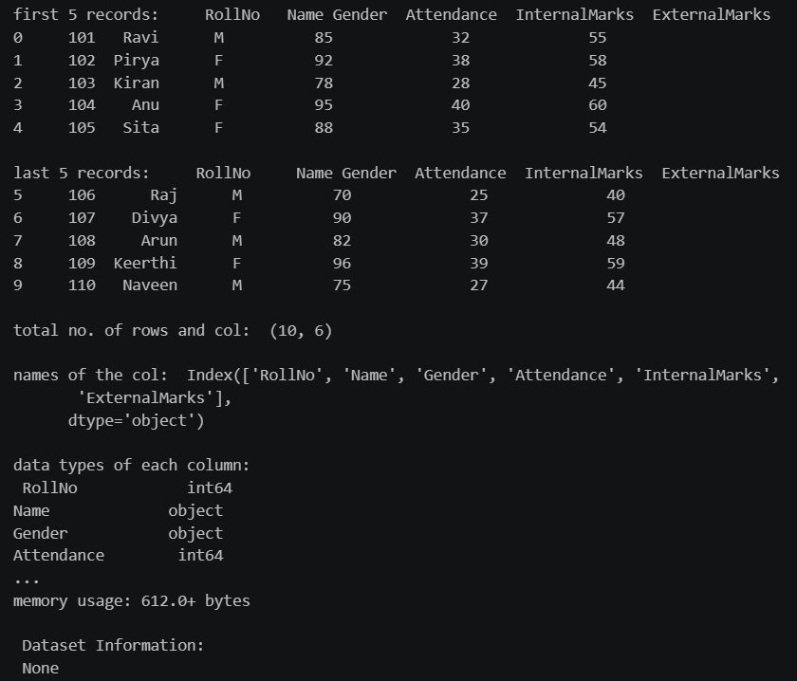
Task B: Statistical Analysis

- Calculate the mean attendance of all students.
- Calculate the average Internal Marks.
- Calculate the average External Marks.
- Find the maximum Internal Marks.
- Find the minimum Internal Marks.
- Find the maximum External Marks.
- Find the minimum External Marks.
- Calculate the standard deviation of Internal Marks.
- Generate summary statistics using describe().

CODE:
print("\nMean Attendance of all students:", df["Attendance"].mean())
print("Average Internal Marks:", df["InternalMarks"].mean())
print("Average External Marks:", df["ExternalMarks"].mean())
print("Maximum Internal Marks:", df["InternalMarks"].max())
print("Minimum Internal Marks:", df["InternalMarks"].min())
print("Maximum External Marks:", df["ExternalMarks"].max()

print(df.describe())

OUTPUT:
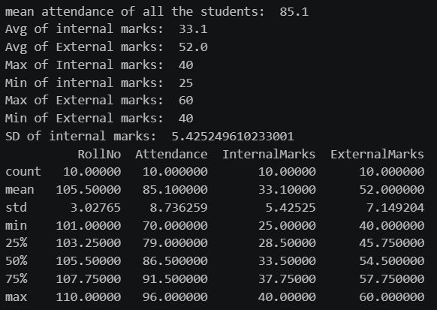

Task C: Data Manipulation

- Create a new column named TotalMarks.
- TotalMarks=InternalMarks+ExternalMarks
- Create a new column named Percentage.
  - Percentage=TotalMarks/100×100
- Display the updated DataFrame.
CODE:
df["TotalMarks"] = df["InternalMarks"] + df["ExternalMarks"]
print("\nNew Table:\n", df)
df["Percentage"] = (df["TotalMarks"] / 100) * 100
print("\nNew Table:\n", df)

OUTPUT:
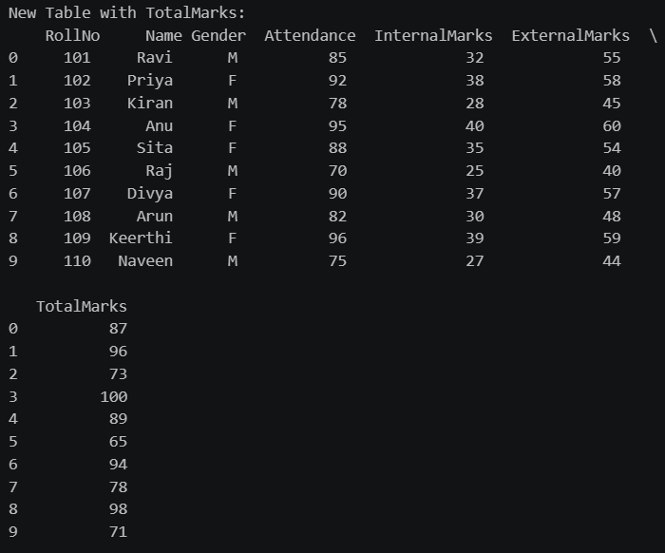
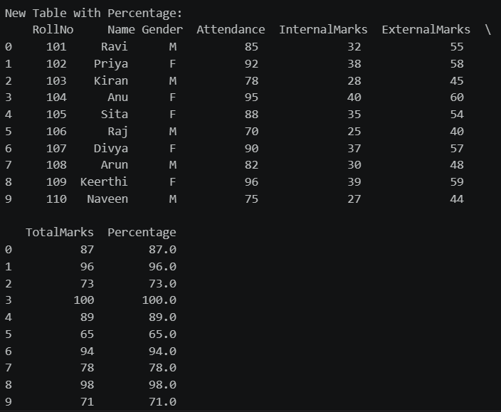
Task D: Filtering and Searching

- Display the details of students whose attendance is greater than 90%.
- Display the details of students whose TotalMarks exceed 90.
- Display the details of female students.
- Display the details of male students.
- Display students whose ExternalMarks are less than 50.

CODE:
print("\nStudents with Attendance > 90:\n", df[df["Attendance"] > 90])
print("\nStudents with Total Marks > 90:\n", df[df["TotalMarks"] > 90])
print("\nFemale Students:\n", df[df["Gender"] == "F"])
print("\nMale Students:\n", df[df["Gender"] == "M"])
print("\nStudents with External Marks < 50:\n", df[df["ExternalMarks"] < 50])

OUTPUT:
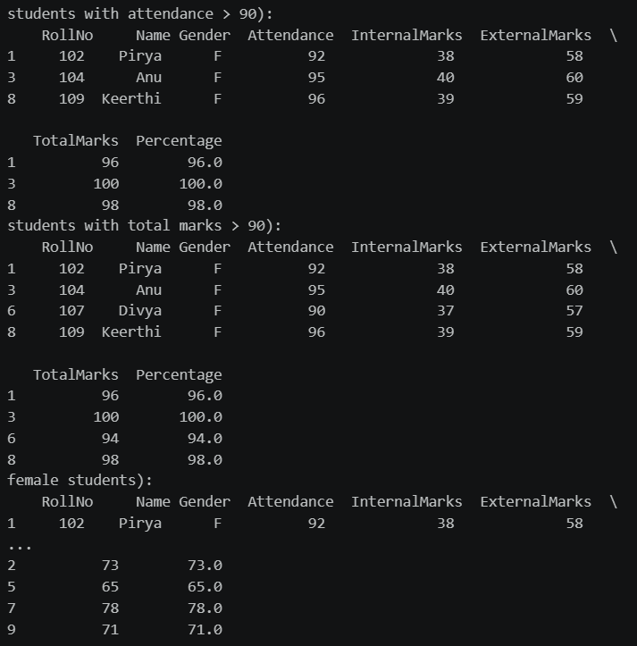

Task E: Ranking and Comparison

- Identify the student with the highest TotalMarks.
- Identify the student with the lowest TotalMarks.
- Display the top three performers based on TotalMarks.
- Display the bottom three performers based on TotalMarks.
- Determine how many students scored above the class average.
CODE:
print("\nStudent with Highest Total Marks:\n", df.loc[df["TotalMarks"].idxmax()])
print("\nStudent with Lowest Total Marks:\n", df.loc[df["TotalMarks"].idxmin()])
print("\nTop 3 Students based on Total Marks:\n",
df.sort_values(by="TotalMarks", ascending=False).head(3))
print("\nBottom 3 Students based on Total Marks:\n",
df.sort_values(by="TotalMarks", ascending=False).tail(3))
avg = df["TotalMarks"].mean()
count = len(df[df["TotalMarks"] > avg])
print("\nClass Average:", avg)
print("No. of students who scored above class average:", count)

OUTPUT:
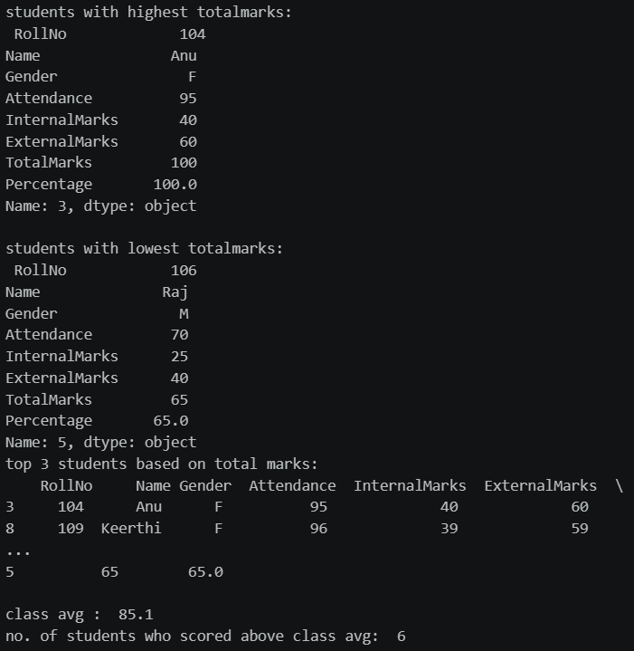

Task F: Group-wise Analysis

- Calculate the average TotalMarks of male students.
- Calculate the average TotalMarks of female students.
- Compare the average attendance of male and female students.
CODE:
gender_grouped = df.groupby("Gender")
print("\nAverage Total Marks by Gender:")
print(gender_grouped["TotalMarks"].mean())
print("\nAverage Attendance by Gender:")
print(gender_grouped["Attendance"].mean())

OUTPUT:
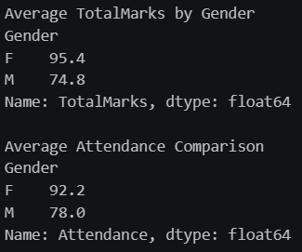

Task G: Data Visualization

- Plot a bar chart showing TotalMarks of all students.
- Plot a histogram of Attendance.
- Plot a pie chart showing the distribution of male and female students.
- Plot a scatter plot between Attendance and TotalMarks.
- Interpret the relationship between Attendance and TotalMarks

CODE:
import matplotlib.pyplot as plt

# BAR GRAPH
plt.figure(figsize=(5,3))
plt.bar(df["Name"], df["TotalMarks"])
plt.title("Total Marks of Students")
plt.xlabel("Students")
plt.ylabel("Total Marks")
plt.show()

# HISTOGRAM
plt.figure(figsize=(5,3))
plt.hist(df["Attendance"], bins=5)
plt.title("Attendance Distribution")
plt.xlabel("Attendance")

plt.ylabel("Frequency")
plt.show()

# PIE CHART
gender_count = df["Gender"].value_counts()

plt.figure(figsize=(4,4))
plt.pie(
gender_count,
labels=gender_count.index,
autopct="%1.1f%%",
startangle=90
)
plt.title("Male and Female Students")
plt.show()

# SCATTER PLOT
plt.figure(figsize=(5,3))
plt.scatter(df["Attendance"], df["TotalMarks"])
plt.title("Attendance vs Total Marks")
plt.xlabel("Attendance")
plt.ylabel("Total Marks")
plt.show()

OUTPUT:
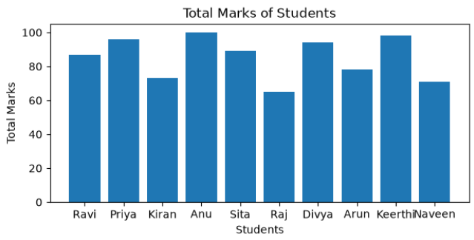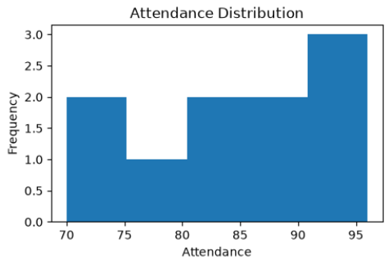

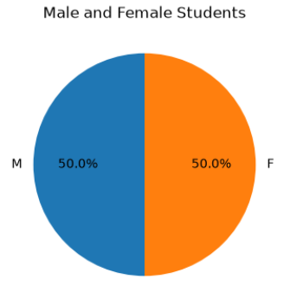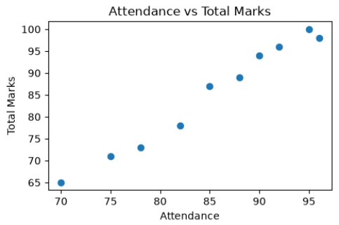
Task H: Observations

- Write any three observations based on the analysis performed.
- State whether higher attendance appears to be associated with better academic performance.
OUTPUT:

1. Female students have a higher average attendance (92.2%) than male students (78.0%).
2. Female students scored a higher average Total Marks (95.4) compared to male students (74.8).
3. Students with higher attendance generally obtained higher Total Marks, indicating a positive relationship between attendance and academic performance.

Yes. Based on the analysis, students with higher attendance generally scored higher Total Marks. Therefore, higher attendance appears to be associated with better academic performance.

